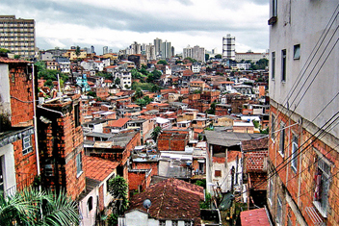 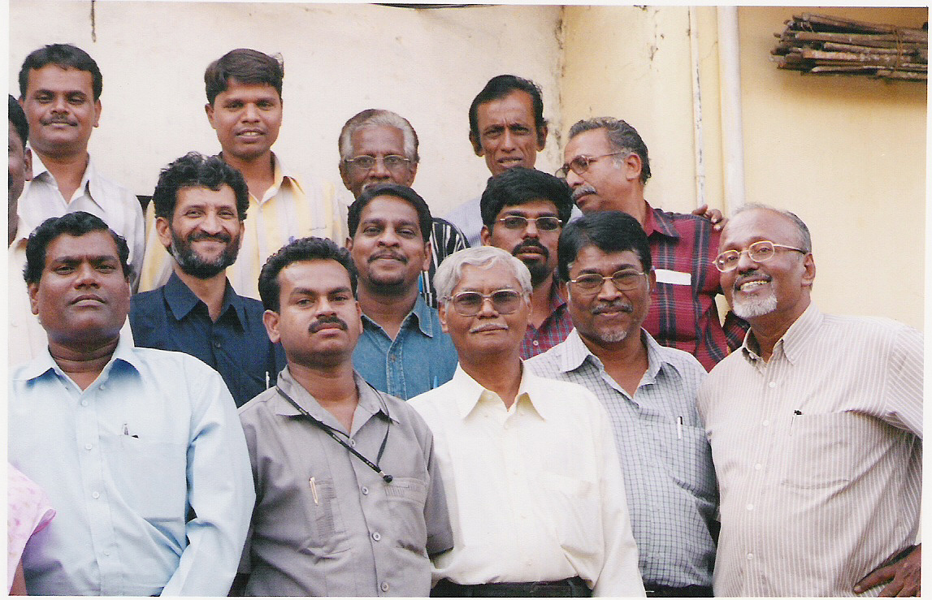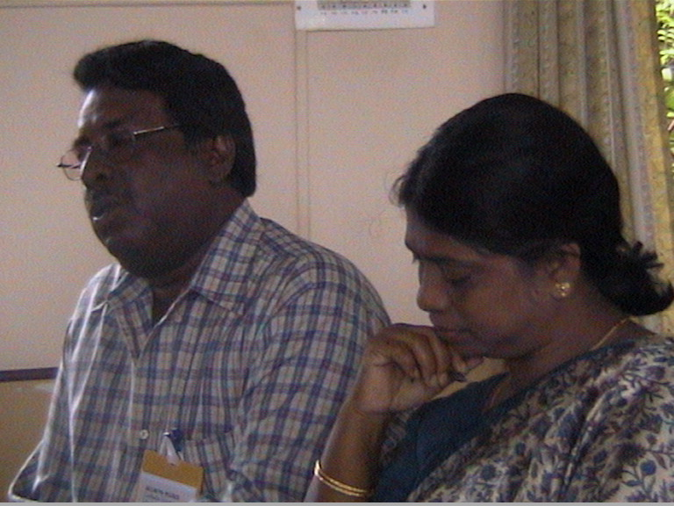

Anointing

Style

Character

Capacity

Skills

Vocation

Mana = style + gift + vocation + anointing + character + skills + capacity

A Capitalist??

One perspective on studying Leadership is to study the qualities of the leader, their personal dynamics. We may examine their gifts, calling (vocation), anointing, character, skills, and capacity. Such an approach meshes well with the Biblical narratives.

*Employing diverse terminology and approaches, scholars have so far identified a number of traits that movement leaders share. We synthesize these views under the concept of “Leadership capital.”*

### Gifts

At birth we inherit some characteristics from our forefathers. These become the basis for our Leadership. As we walk with the Holy Spirit, he adds to these spiritual gifts. These become evident to those around us, who affirm and appoint us to roles appropriate to those gifting. Movement Leadership has to do with the five Leadership (eldership) [giftings of Eph 4: 11, 12](http://urbanleaders.org/620Leadership/02qualities/Eph41112.ppt), plus that of a the gift of deacon, as these are developed into broad spheres of operation. We will do some analysis of these giftings with a [5 Fold Gifts Questionnaire](http://urbanleaders.org/620Leadership/02qualities/Spiritual%20gifts/Fiveministries%20questionnaire.htm). Heschel in [the Prophet](http://urbanleaders.org/620Leadership/92Readings/articles/Heschel-Prophets.pdf) gives a biblical exegesis on the prophetic role which complements Max Weber's theories on the prophetic. Wagner teaches on [Apostolic Ministry](http://urbanleaders.org/620Leadership/92Readings/articles/Wagner-New%20Apostolic%20Churches.pdf) as mega-church pastor, basing his exegesis on authority, an approach rejected by most apostles.

The gifts and call of God are irrevocable (Rom 11:29). These two are entwined together. Where he calls, he gifts. The call is that driving sense of long-term destiny usually involving a direct encounter with God.

The vocation is the long disciplines day by day in the direction of that calling.

The “call” is often an experience of great depth and significance, an encounter directly between God and his man or woman.

*Vocare*, in Latin, to call, is the source of our words vocal, vocabulary, evoke… the vocation is an expression of the voice of God through us, in both our being and in our words. The power of words is that of the source. If the President asks you to do something you would do it, even if it didn’t make much sense. The source is the basis of significance.

Leadership capital is thus maximizing the connection to the authority, and the range of our voice.

Examine Luther and Calvin's concepts of vocation.

What are the essential character qualities that differentiate movement leaders from others? Discuss.

Greenleaf builds his whole theory of Leadership around the theme of [servanthood](http://urbanleaders.org/620Leadership/92Readings/articles/Greenleaf-Servant%20Leadership.pdf). Business leaders have come up with 9 qualities of Leadership but these fall far short of the Biblical model.

[Click here](http://urbanleaders.org/620Leadership/02qualities/character.html) to view responses from others.

Kim Farnham analyzes how he emphasis on various traits changes in a new culture. This is clearly a broadening of leadership skills, traits and characteristics.

Skills

Many of the principles of Leadership involve learned skills. This often begins with technical expertise in an area of Leadership or ministry. Step by step we add to our toolbox of skills, a piece there, a skill there. Till eventually we have a breadth of skill for whatever circumstance.

The following is one set of analysis of outstanding [Leadership skills](http://www.guardian.co.uk/society/joepublic/2010/dec/08/Leadership-voluntary-sector-difficult-timeshttp://www.guardian.co.uk/society/joepublic/2010/dec/08/Leadership-voluntary-sector-difficult-times).

Here is an [A-Z of characteristics of Entrepreneurs](http://knol.google.com/k/characteristics-of-an-entrepreneur)

### Resource Building

The context, people and financial resources determine the extent to which the above characteristics become effective. These are often built up over long periods of time, or a leader may be appointed to a senior Leadership role of an existing resource base, having shown stewardship at a similar level.

### Readings

* Berger, Peter and Gordon Redding. (2011) *The Spiritual Form of Capital.* Anthem Press.
* Greenleaf, R. K. (1977). [*Servant Leadership : a Journey into the Nature of Legitimate Power and Greatness*](http://urbanleaders.org/620Leadership/92Readings/articles/Greenleaf-Servant%20Leadership.pdf). Mahwah, NJ, Paulist Press.
* Heschel, A. J. (1962). [*The Prophets*](http://urbanleaders.org/620Leadership/92Readings/articles/Heschel-Prophets.pdf). New York, Harper & Row.
* Sanders, J. O. (1967). [*Spiritual Leadership*](http://urbanleaders.org/620Leadership/92Readings/articles/Sanders-Spiritual%20Leadership.pdf). Chicago, Moody Press.
* Wagner, C. P. (1998). [*The New Apostolic Churches*](http://urbanleaders.org/620Leadership/92Readings/articles/Wagner-New%20Apostolic%20Churches.pdf). Ventura, Calif., Regal

**A long obedience in the same direction**

Movement Leadership

Continued…

# Qualities of Movement Leaders

Lead from the front, but don’t leave your base behind

- Nelson Mandela

Gifts

Leadership Capital

Viv Grigg

Leadership Capital

God gives a particular empowerment of his Spirit on us related to our calling. It is not something of our making but supernatural.

* There are early signs of his presence coming when we function in certain types of ministry.
* At times this may be imparted from another with spiritual gifts.

Nazarene pastors in slum training in Mumbai

Social Capital, Spiritual Capital

### Anointing

Spiritual capital is a particular form of social capital that is associated with membership of religious movements and certain symbols.

The concept of social capital was introduced in the sociological literature by James Coleman and in the 1990’s popularized by Robert Putnam’s *Making Democracy Work*.

Membership in certain groups or networks yields economic benefits. Putnam distinguishes between bonding and bridging social capital.

* Bonding enables us to work closely with our intimate associates (the team)
* Bridging enables us to work with others outside of our social group (the network, the movement).

## Calling, vocation, being the voice, voicing the voice

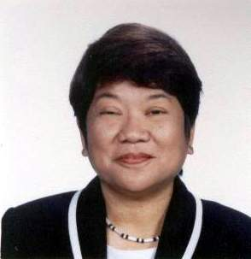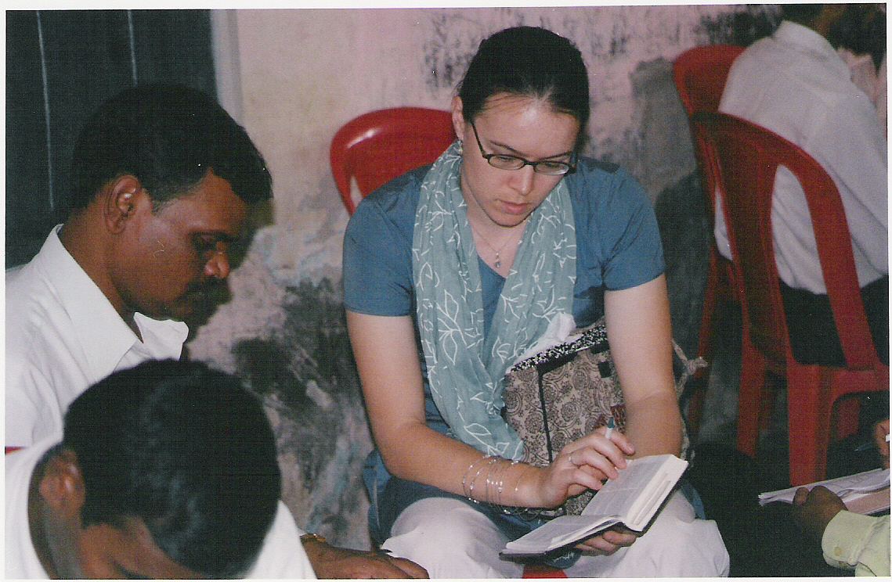

### Capacity

Capacity is a measure of the breadth of responsibility we are capable of carrying. The scriptures tell us to have a sane estimate of our capacities.

Some are called, gifted and have the capacity to lead at a local church level, some to the community, some to a movement, some to the city, some to a nation, some internationally.

The gifts function at each level but in different ways. Lives of leaders can be mapped along a timeline evidencing expanded capacity.

### Character of the Leader

Lead from the back and let others believe they are in front. - Nelson Mandella

In this unit students will:

* Become intrigued by possibilities of defining spiritual capital
* Grasp the eight elements that feed into spiritual mana
* Consider the long-term capacities they possess and how to best develop them.

### Learning Objectives